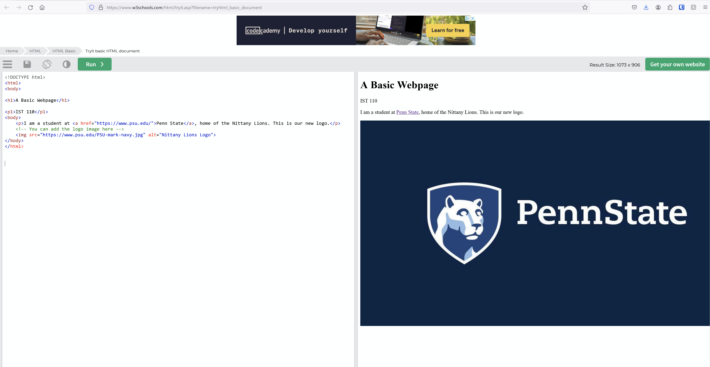

<!DOCTYPE html>

<html>

<body>

<h1>A Basic Webpage</h1>

<p1>IST 110</p1>

<body>

<p>I am a student at <a href="https://www.psu.edu/">Penn State</a>, home of the Nittany Lions. This is our new logo.</p>

<!-- You can add the logo image here -->

<img src="https://www.psu.edu/PSU-mark-navy.jpg" alt="Nittany Lions Logo">

</body>

</html>